Project Title
Employee Raise Issue – Record Producer & Service Portal Integration Guide

Name: Repalle Himaja Sri
College: Chalapathi Institute of Engineering and Technology (CIET)
Email: y23cai047@chalapathiengg.ac.in

Project overview:
The main objective of the Employee Raise Issue project is to develop a simple and efficient solution in ServiceNow that allows employees to easily report workplace issues, requests, or concerns through a self-service portal
The system uses a Record Producer to collect the required information from employees in a structured format and create an issue record in ServiceNow. The solution includes appropriate form fields, validations, client-side scripting, and portal integration to ensure that issues are submitted accurately and consistently
The project also aims to provide a user-friendly Service Portal interface where employees can access the Raise an Issue option easily. By organizing issue submission and management within ServiceNow, the solution improves visibility, reduces manual effort, and helps support teams handle employee issues in a more organized and efficient manner.

Table of Contents:
- Introduction
- Project Objectives
- Key Features
- Creating a Custom Application
- Creating a Custom Table and Fields
- Creating UI Policies and Dependency
- Creating a Record Producer
- Creating a new Service Portal
- Creating Widgets and Adding to the Page
- Testing and Validation
- Conclusion

Introduction:
  - In today’s organizations, employees regularly encounter different workplace concerns, technical problems, and service-related issues that require timely attention and resolution. When these issues are reported through traditional manual methods, it can result in delays, incomplete information, communication gaps, and difficulty in tracking the progress of submitted issues.
  - To overcome these challenges, the Employee Raise Issue – Record Producer & Service Portal Integration project provides a centralized and user-friendly solution using the ServiceNow platform. The project enables employees to submit their issues through a customized Service Portal, where a dedicated Raise an Issue widget provides quick access to the issue submission form. The Record Producer captures the required information and creates an issue record in the customized
ServiceNow table.
  - This solution improves the overall issue-reporting process by providing an organized platform for submitting and managing employee concerns. The integration of the Service Portal, Record Producer, UI Policies, and customized widgets helps make issue submission simpler, improves data consistency, and provides better accessibility and visibility for both employees and the teams responsible for resolving their issues.

Project Objective:
The main objective of the Employee Raise Issue project is to develop a simple and efficient solution in ServiceNow that allows employees to easily report workplace issues, requests, or concerns through a self-service portal.

The system uses a Record Producer to collect the required information from employees in a structured format and create an issue record in ServiceNow. The solution includes appropriate form fields, validations, client-side scripting, and portal integration to ensure that issues are submitted accurately and consistently.
The project also aims to provide a user-friendly Service Portal interface where employees can access the Raise an Issue option easily. By organizing issue submission and management within ServiceNow, the solution improves visibility, reduces manual effort, and helps support teams handle employee issues in a more organized and efficient manner.

Key Features:
- Employee self-service portal for easily raising workplace issues and concerns.
- Record Producer to capture employee issue details and automatically create records in the designated ServiceNow table.
- Customized issue form with relevant fields to ensure complete and structured information is collected.
- Dynamic form behaviour and validations using UI Policies and client-side scripts to improve data accuracy.
- Customized Service Portal widgets such as Our Commercial Services and Raise an Issue for a simple and attractive user interface.
- Easy issue submission through the Raise Ticket option, providing employees with quick access to the issue-raising form.
- Centralized issue management by storing all submitted employee issues in a dedicated ServiceNow table.
- Improved visibility and tracking of employee issues, helping support teams manage and resolve concerns efficiently.
- Testing and validation to ensure that the portal, Record Producer, forms, and issue-record creation work correctly.

ServiceNow Developer Setup:

Create a Developer Account
  - Go to ServiceNow Developer Portal(https://developer.servicenow.com/dev.do). Sign up for a free developer account and fill out the following details.

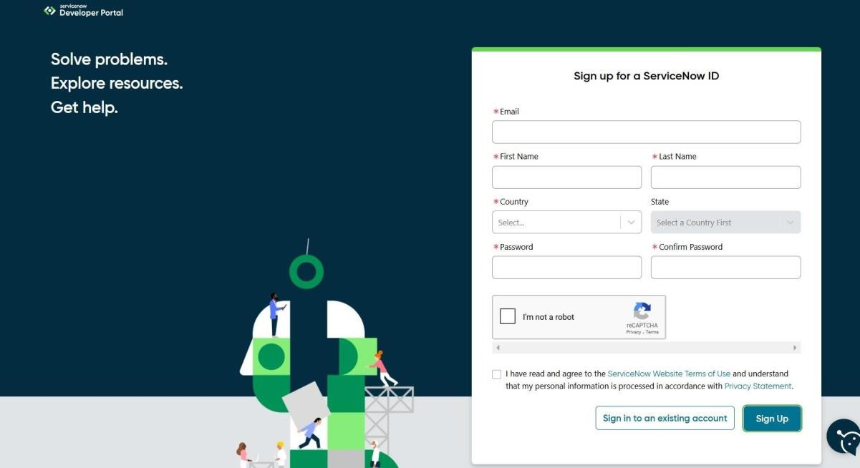
  - After signing up, you will get a verification mail to your provided email id. After the verification your ServiceNow Developer Portal Home Page will appear
  - Now click on start building it will take you to the section where you can request a Personal Developer Instance (PDI) or start using App Engine Studio and other tools.
  - Profile Icon (Top Right Corner) → Manage your account, request instances, and check your developer profile.

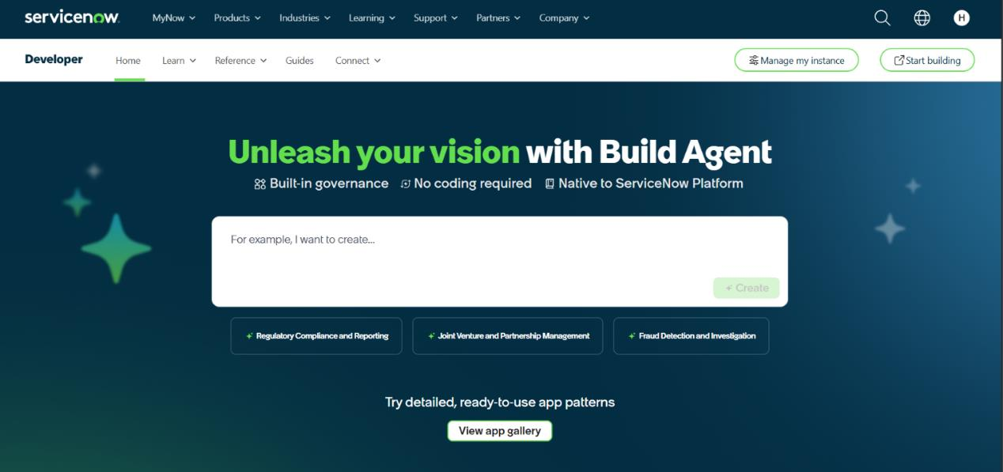

Project Implementation in ServiceNow :
After the instance building is completed, the page will be directed to your creator studio Creator Studio in ServiceNow provides a guided, no-code environment to build applications quickly. It is especially useful for creating request-based applications by defining forms, setting up tables, and automating workflows.

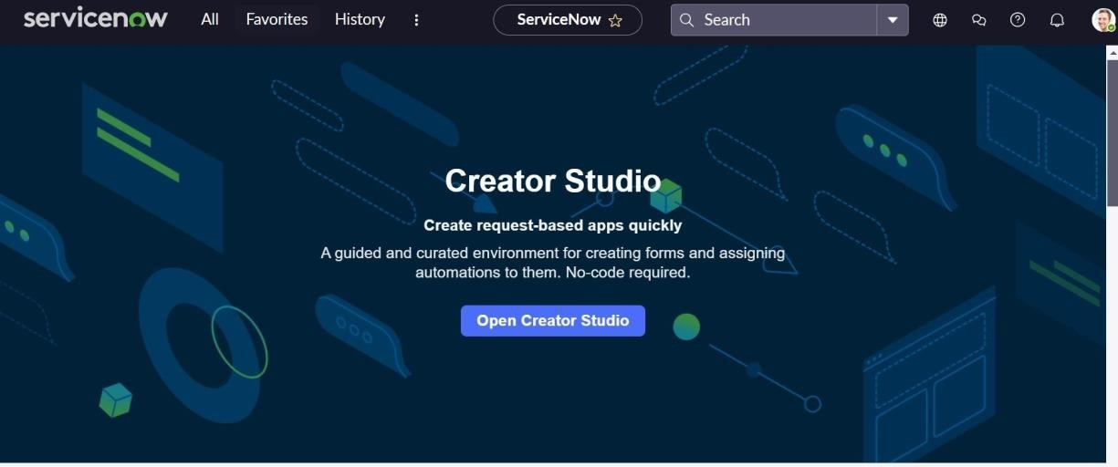

Creating a Custom Application:
- Navigate to All → App Engine → App Engine Studio.
- Click on Create and select Application to create a new application.
- Name: Employee Raise Issue
- Scope: Scoped
- Enter the required application details.
- Click on Continue.
- After creating the application, return to the ServiceNow home page and reload the page.
Verify that Employee Raise Issue appears as the current application
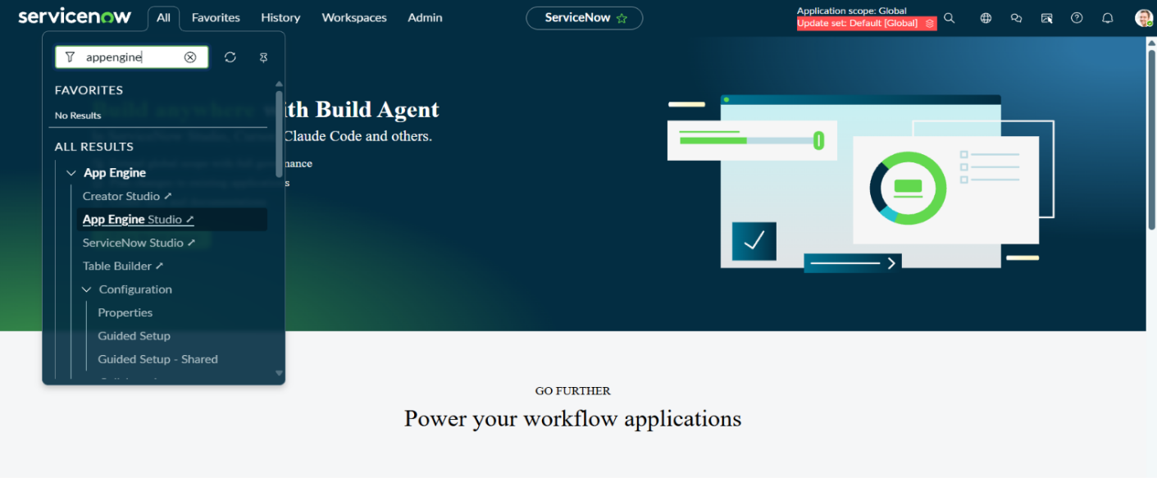

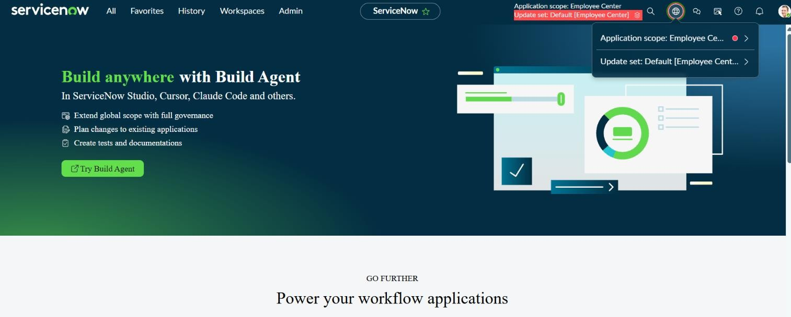

Creating a Custom Table and Fields:

- Steps To Create Tables:
  - Navigate to All → System Definition → Tables
  - Click New on the top-right corner.
  - Label: Employee Raises Issue
  - Name: This field is automatically populated by ServiceNow based on the table label.
  - Under Controls, enable Auto number if required.
  - Enter the required table details.
  - Click Submit or Save to create the table.
  - After creating the table, verify that Employee Raises Issue appears in the Tables list.
  - Save the changes

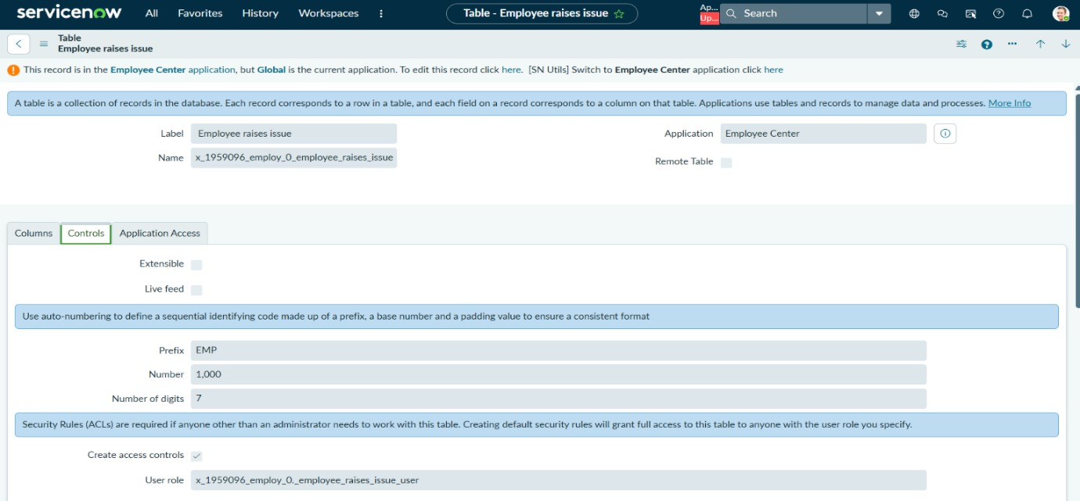

Steps to Create Fields:
  - Open the Employee Raises Issue table.
  - Under Related Links, click on Show Form.
  - Open the Context Menu on the form.
  - Select Configure → Form Design.
  - In Form Design, create and add the required fields.
  - Select the appropriate Field Type and provide the required Field Label.
  - Configure the fields according to the project requirements.
  - Click Save to apply the changes.
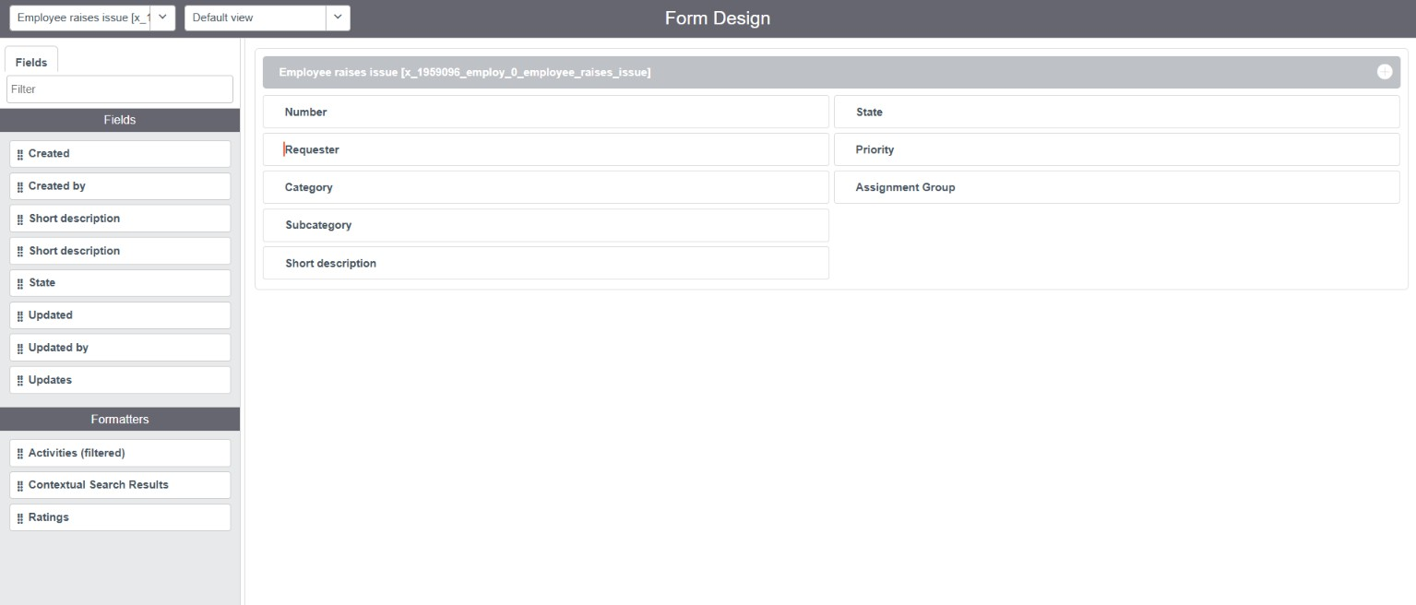

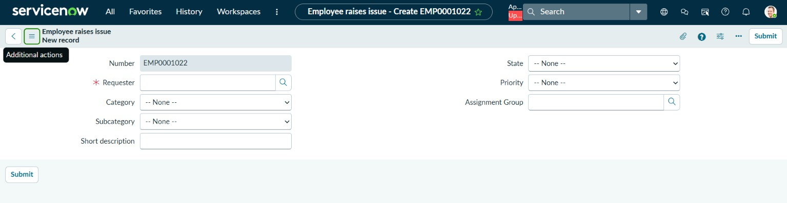

Creating UI Policies and Dependency.

- Creating UI Policies:
- Go to All menus → Search UI policies. On the top right corner click New to create a new UI Policy.
- Table: Employee raise issue
- Short description: When the state changes to new then short description is mandatory
- Filter condition (When to apply): State is New
- Save the form.
- Under Related Links → UI Policy Action Section,
- click New.
- Select Field: Short description
- Mandatory: True
- Visible: Leave alone
- Read only: Leave alone
- Click Submit and then click Update
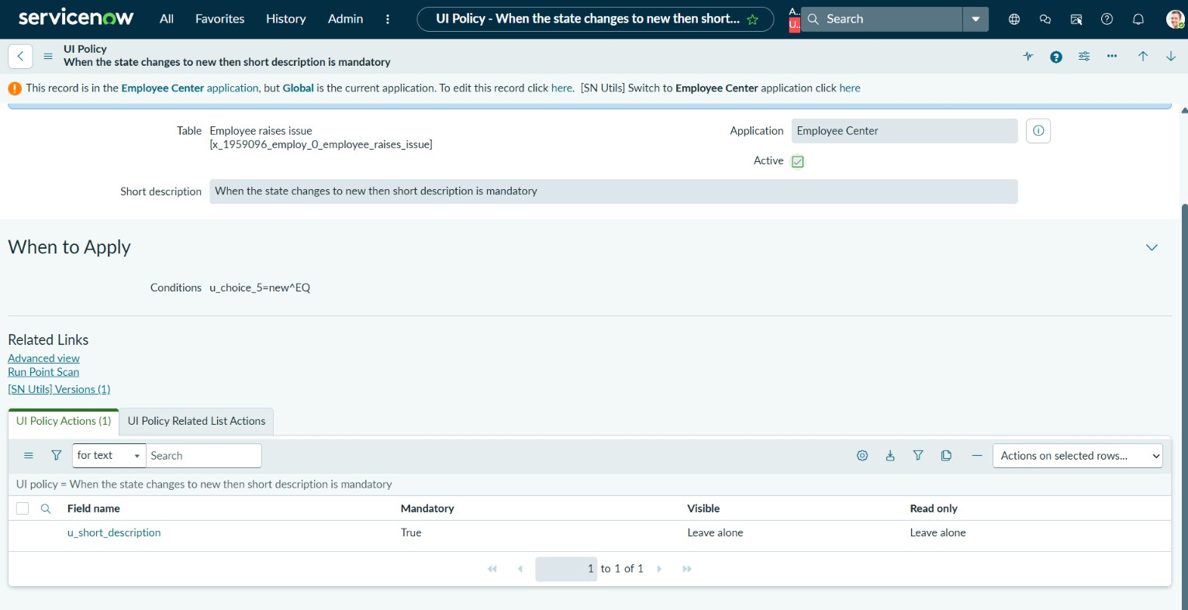

Making Number field Read Only:
- Navigate to UI Policies and click New on the top right corner.
- Table: Employee Raise issue
- Short description: Number field will read only No filter condition applies. Save the form.
- Under Related List → UI Policy Action Section,
- click the New button.
- Choose the Field: Number Read only: True
- Mandatory: Leave alone
- Visible: Leave alone
Click Submit and then click Update

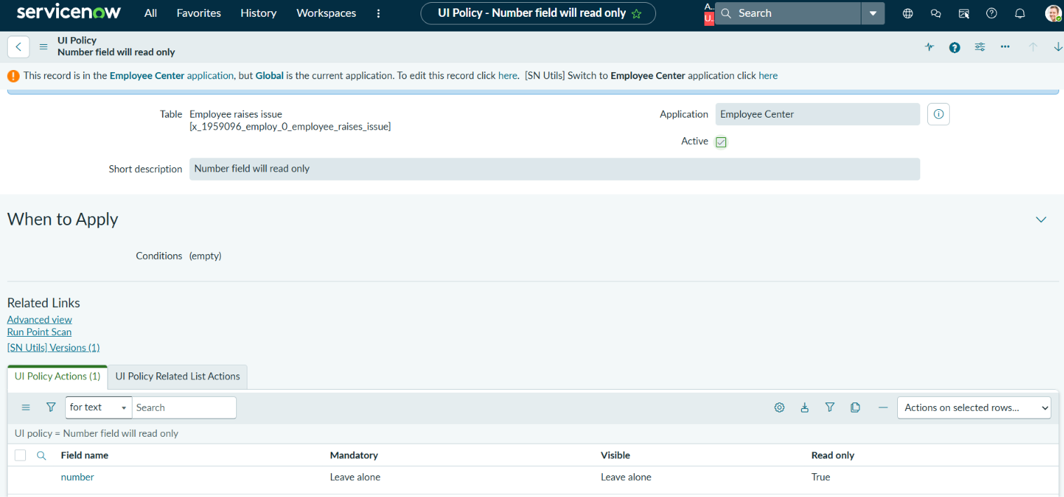

Creating Dependency:
  - Open the Employee Raise Issue table form.
  - Right-click on the Subcategory field and select Configure Dictionary.
  - A new form will open. Under Related Links, select Advanced View.
  - In the Dependent field option, select Category.
  - Under Related Links, select the Choices section.
  - Add the required Subcategory choices and enter the corresponding backend value of the Category.
  - Configure the Subcategory choices based on the selected Category.
  - Set the following Category and Subcategory values: Network → VPN, Hardware → Laptop, Software → Server Access → Forgot Password
  - Save the changes.
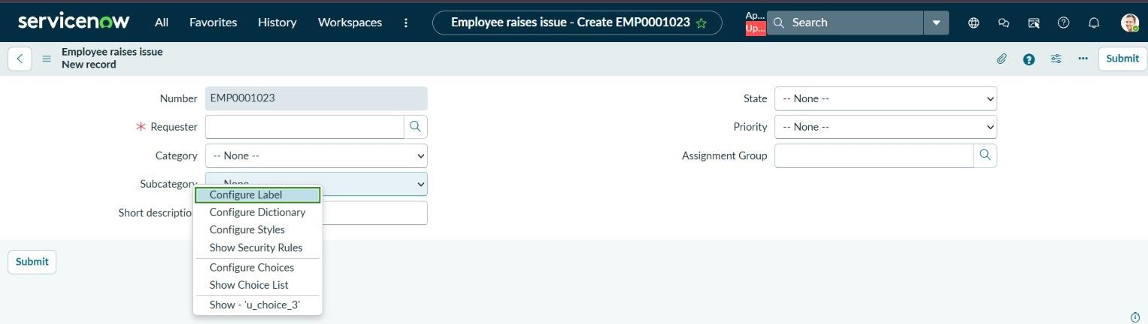

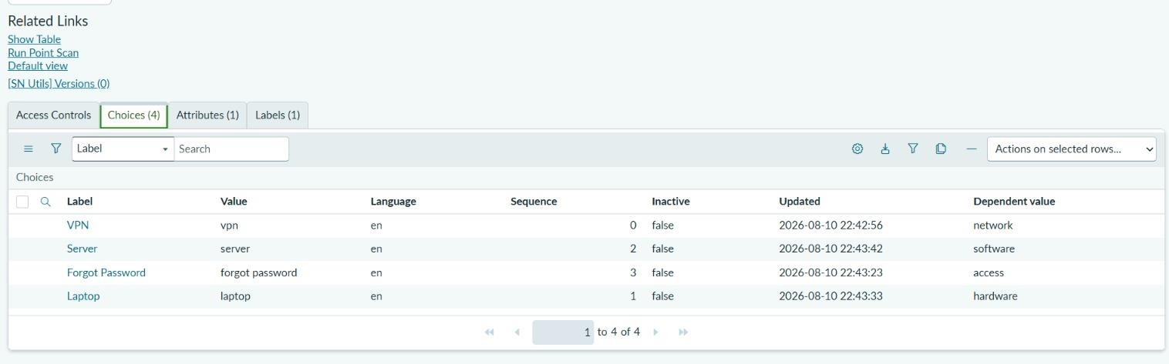

Creating a Record Producer:
- Navigate to All → Service Catalog → Catalog Definition → Record Producers.
- Click the New button on the top-right corner.
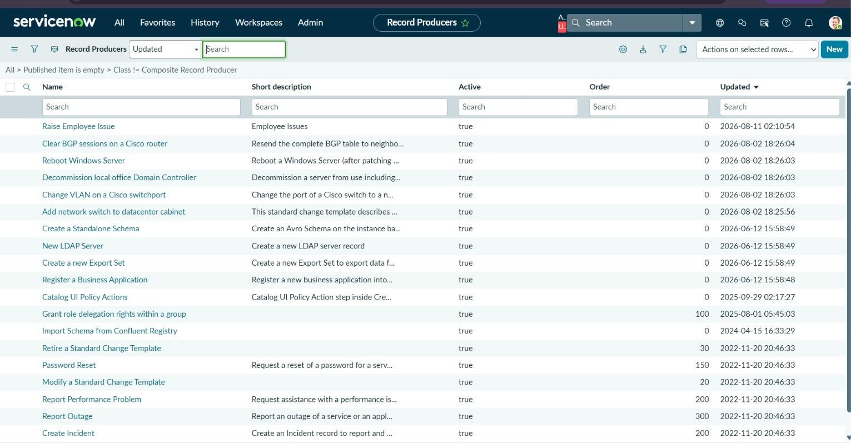

- Enter the Name as Raise Employee Issue.
- Select Employee Raise Issue in the Table field.
- Enter a suitable description in the What it will contain field.
- In the Accessibility section, select Service Catalog in the Catalog field.
- Select Service in the Category field.
- Add an image in the Picture field.
- Enter the table name in the Meta name field.
- Click Save to create the Record Producer.
- Under Related Links, open the Variables section.

- Click New to create a variable.
- Select the required variable Type based on the Employee Raise Issue table.
- Enable the Map to Field option.
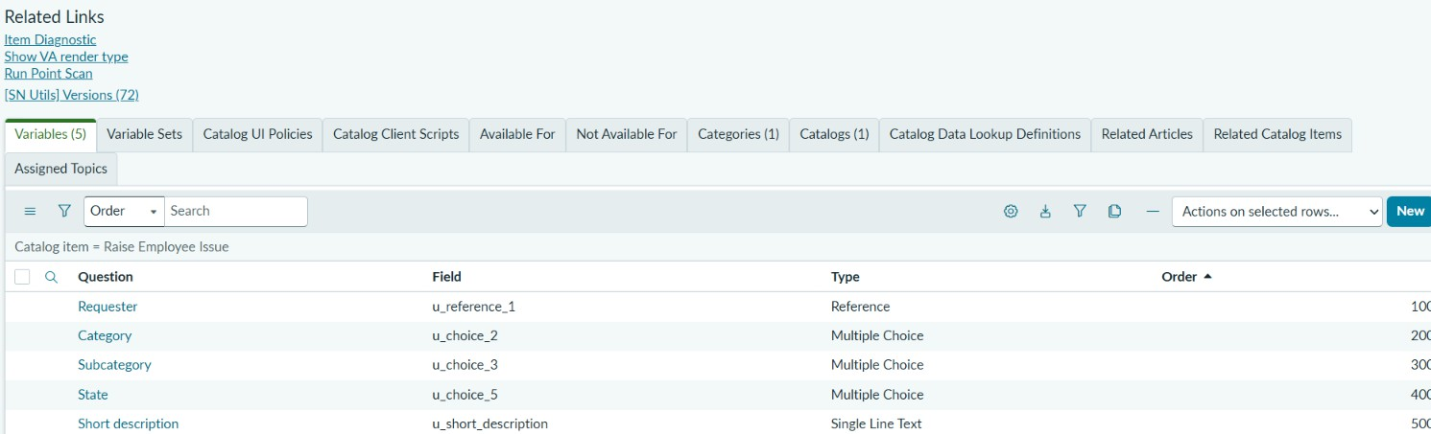

- Select the corresponding Field.
- Enter the Order as 100 for the first variable, 200 for the second, 300 for the third, 400 for the fourth, and 500 for the fifth variable.
- Enter the required question in the Question field. The Name field will be automatically populated.
- Create the following five variables:
- Requester Name – Reference – sys_user
- Which Category – Choice – Network, Software, Hardware, Access
- What is Subcategory – Choice – VPN, Laptop, Server, Forgot Password
- Which State is this Issue – Choice – New, In Progress, Resolved, Closed
- Short Description – Single Line Text – String
- Save each variable after creating it.
- After creating all five variables, save the Record Producer.
- Verify that the Raise Employee Issue Record Producer is created successfully.

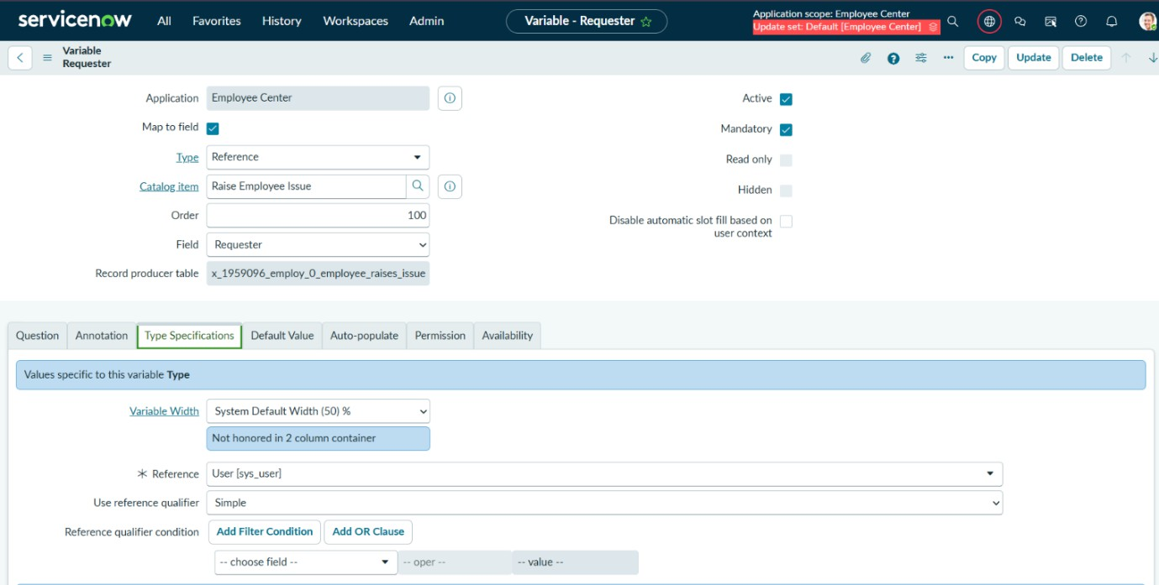

  - Now open a new tab with this link {{https://dev218595.service-now.com/}.

  - Add Suffix as (sp). And search with the table name in the search bar.

  - Then it displays in the way of the picture below
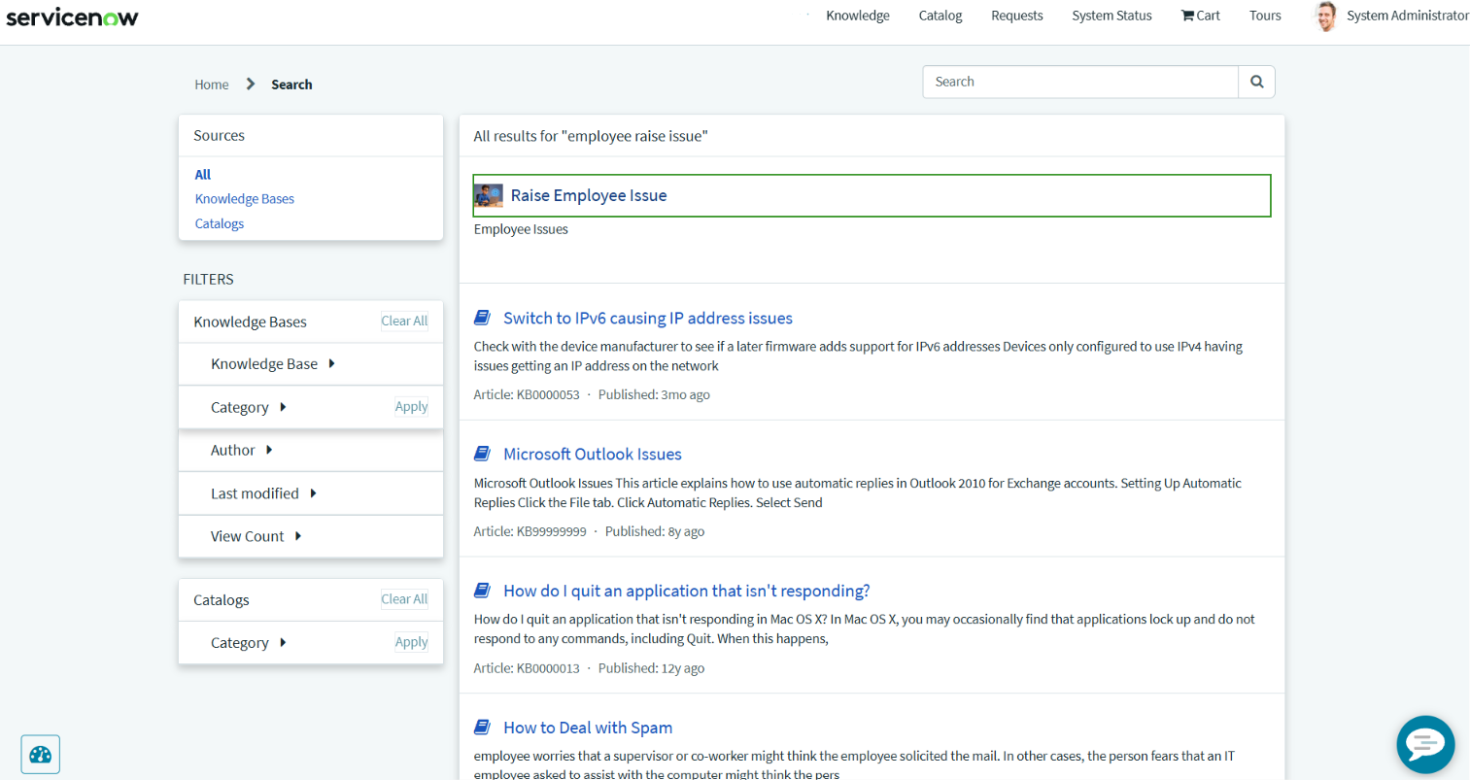

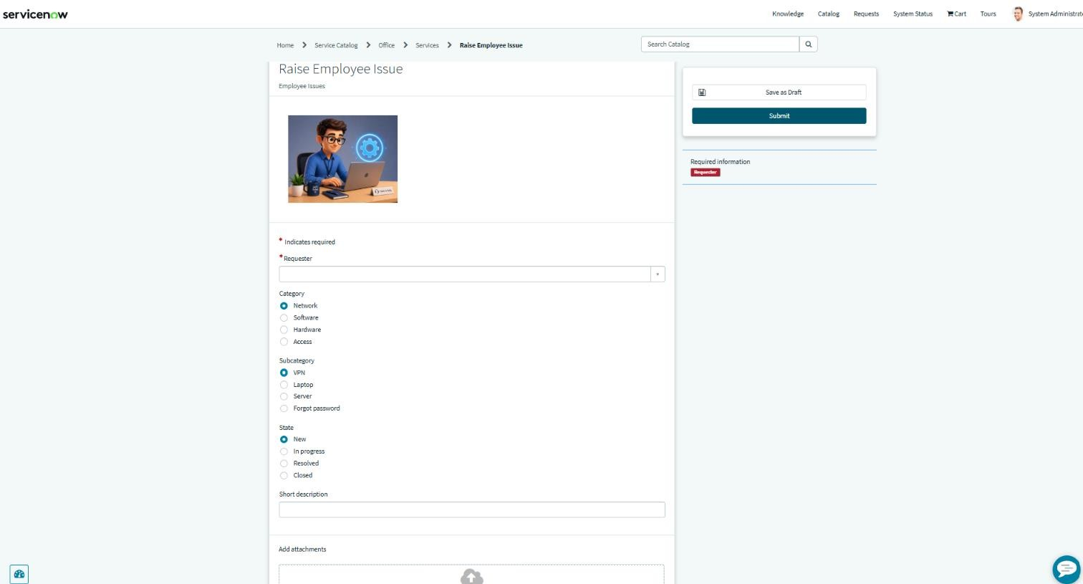

Creating a new Service portal:
- Navigate to All → Service Portal → Service Portal Configuration.
- Click New on the top-right corner to create a new portal.

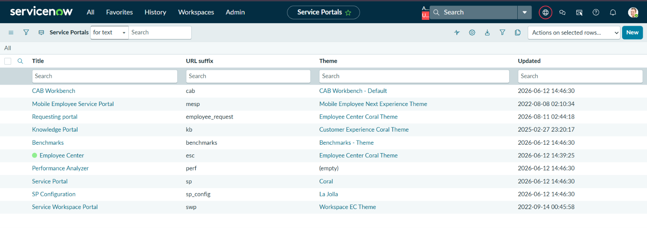
- Enter the Title as Requesting Portal.
- Enter the URL suffix as employee_request.
- Select ec_standard_home as the Homepage.
- Select esc_knowledge_home as the KB Home Page.
- Select login as the Login Page.
- Upload the required image in the Logo field.
- Select Employee Center Menu as the Main Menu.

- Select 404 as the 404 Page.
- Select Employee Center Coral Theme as the Theme.
- Click Save to create the Service Portal.

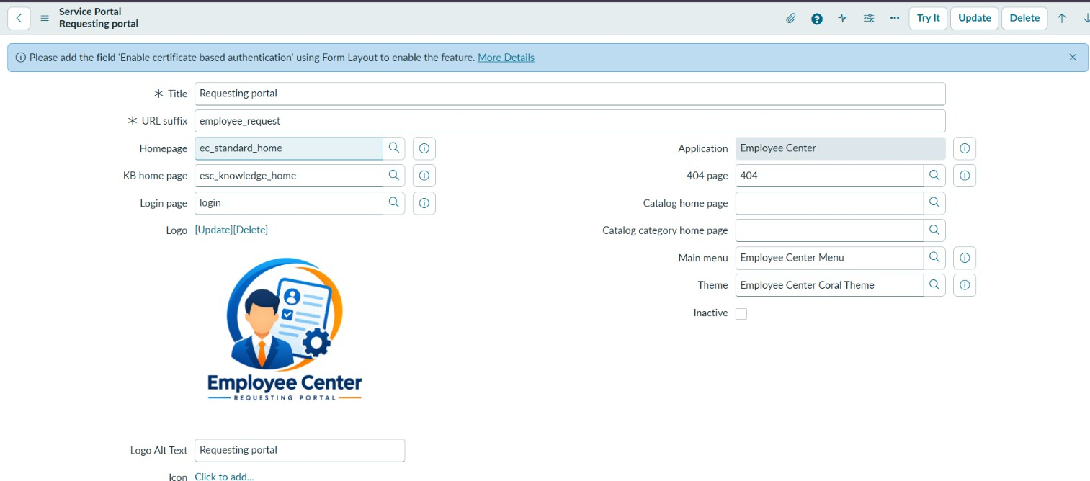

Creating A New Employee Center Portal Page:
  - Navigate to All Menu --> type Service portal.
  - Select Pages module and Click New button on the top right corner.
  - Give title as Employee Center Portal Page.
  - And ID as employee_center_portal_page.
  - Click save from the context menu.

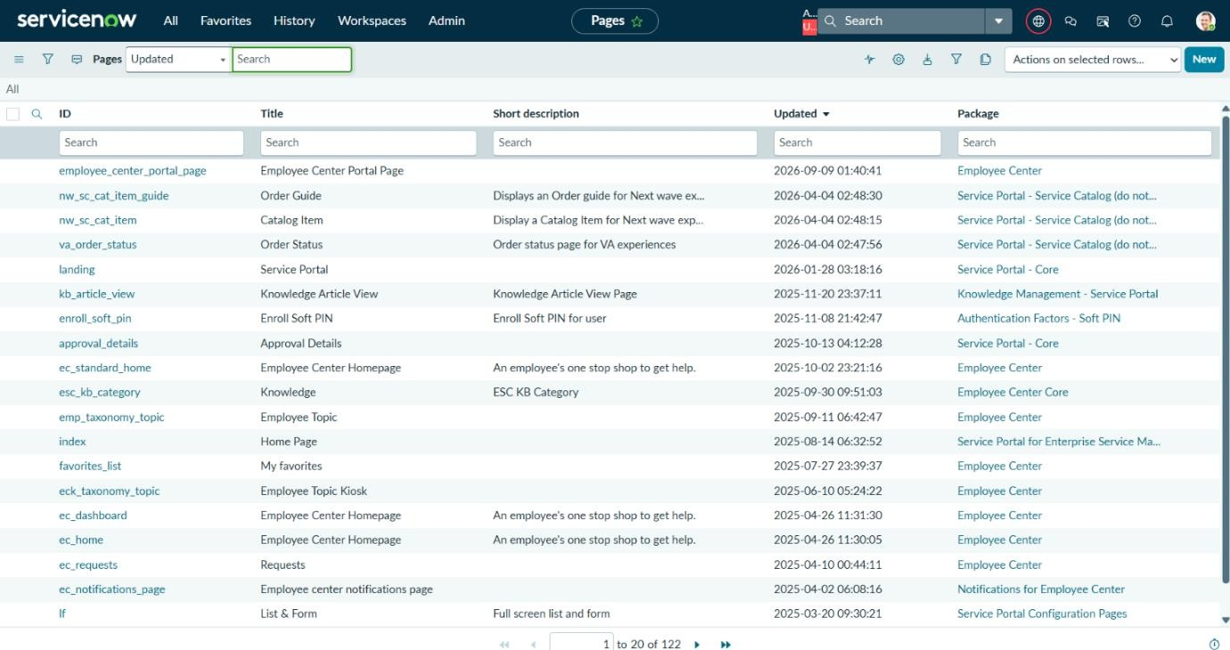

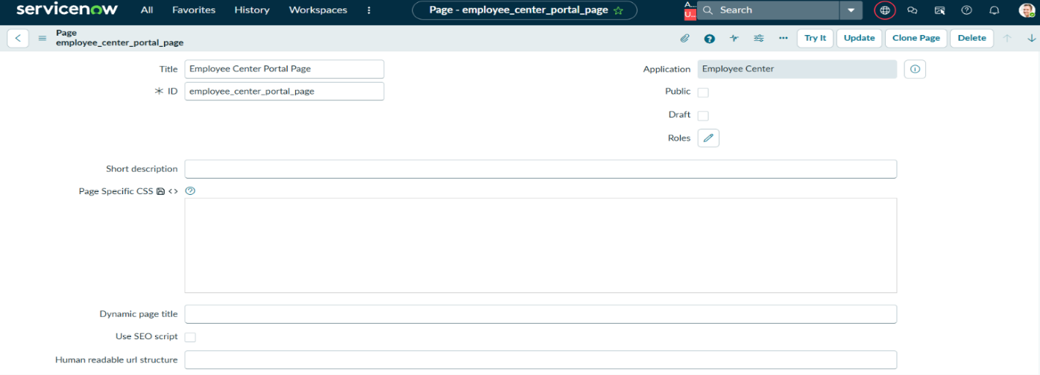

Creating Widgets and Adding to the Page:

Left Widget Creation
    - Navigate to Service portal Configuration Under Service portals.
    - Click on the Widget Editor.
    - Click Create a new widget
    - Widget 1 Name: Commercial widget.
    - Then Click Submit.
    - Now we need to write code for HTML , CSS.
    - Enable the Templates for each one.
    - We can Enable Preview / hide using the Eye symbol.
    - For this Widget we used Flouting the words and based on coarser moves.

Right Widget Creation:
  - Navigate to Service portal Configuration Under Service portals.
  - Click on the Widget Editor.
  - Click Create a new widget
  - Widget 1 Name: Link redirect.
  - Then Click Submit.
  - Now we need to write code for HTML , CSS and Client script.
  - Here we also use the Client Script to Redirect the page by using sys_id of record producer.
  - Enable the Templates for each one.
  - We can Enable Preview / hide using the Eye symbol.
  - For this Widget we used Flouting the words and Premium based on coarser moves

Adding 2 Widgets to the Page:
  - Here we are using an already existing page.
  - Page Name: Employee Center portal page.
  - Navigate to Service portal Configuration under Service portal.
  - Now select the designer.
  - Search for the Employee Center homepage and select it.
  - Now create a container with 6*6.
  - Add the Widgets based on which side we need to display them.
  - Search for the widgets and drag and drop them.
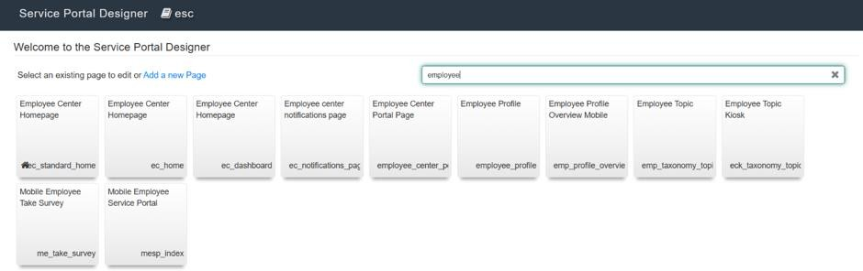

Testing and validation:
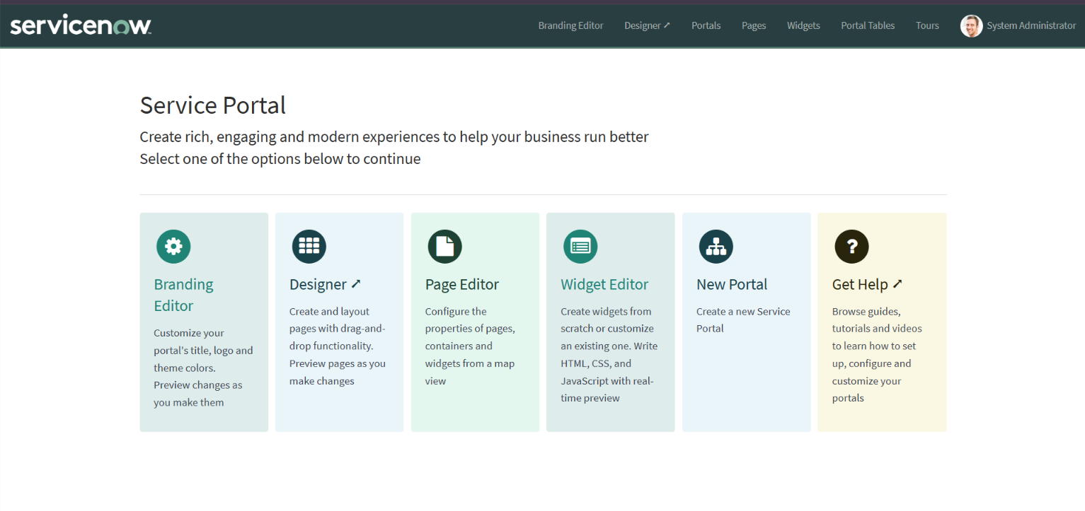
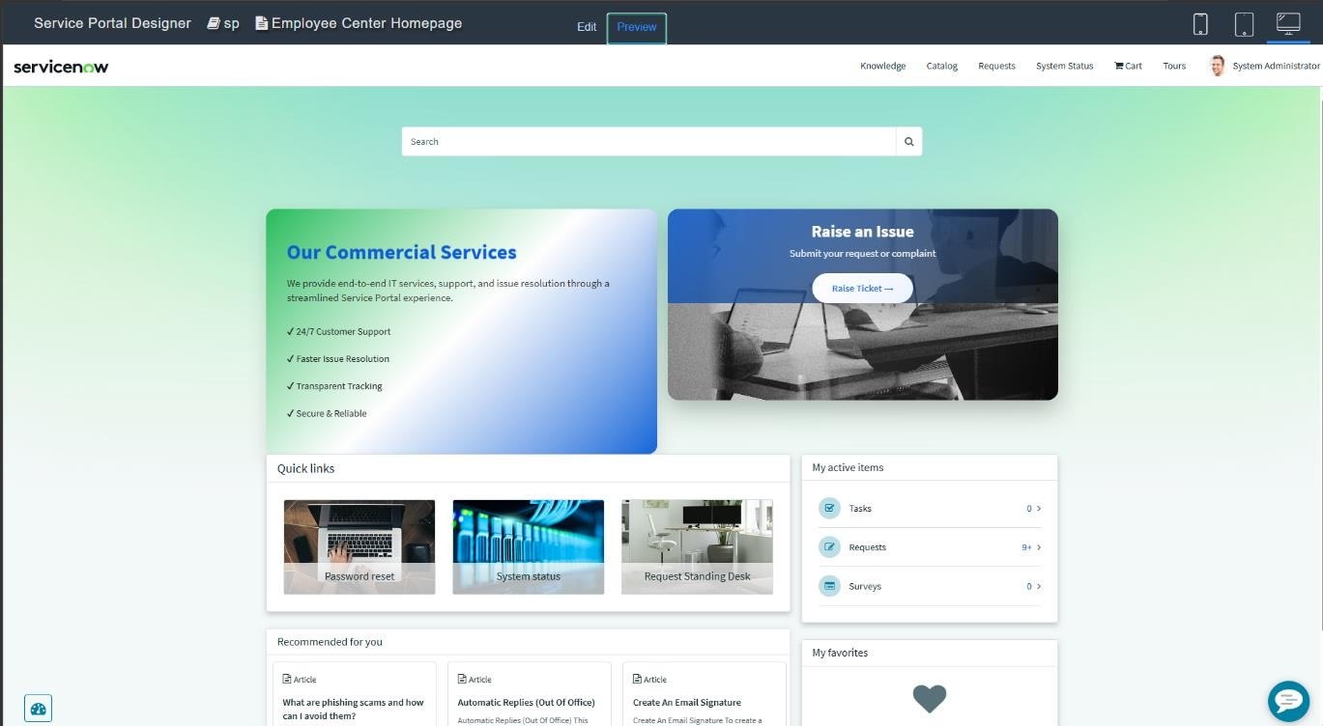
- Open the new Browser tab and paste the URL.
- [ https://dev299334.service-now.com/ /employee_request ].
- We can observe the Image and Icon Picture that we added.
- Then click enter and scroll down to see the Created widgets.
- Move the course to see the flouting of the two widgets.
- Click on the Link button shows the Rise ticket.
- Which opens the record producer to fill the details of the Employee and about the issue.
- Then Click the Submit button.
- And also observe the changes fields and restrictions made using UI policies and

dictionary override.
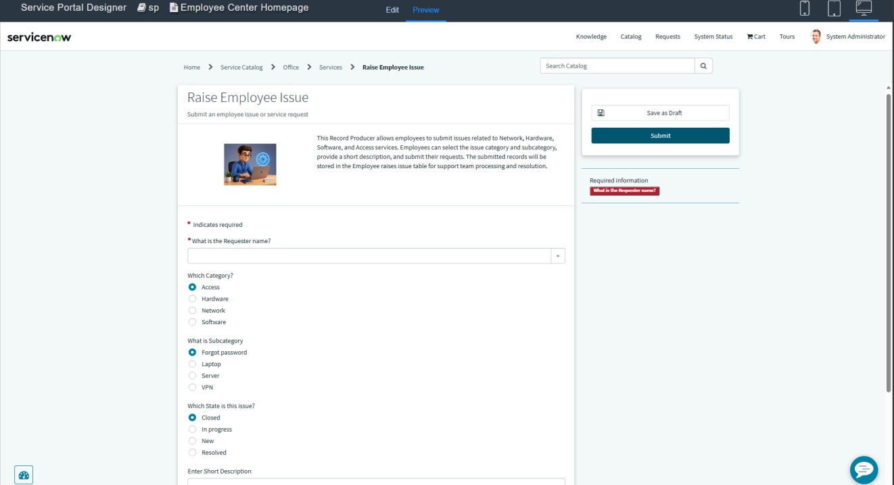

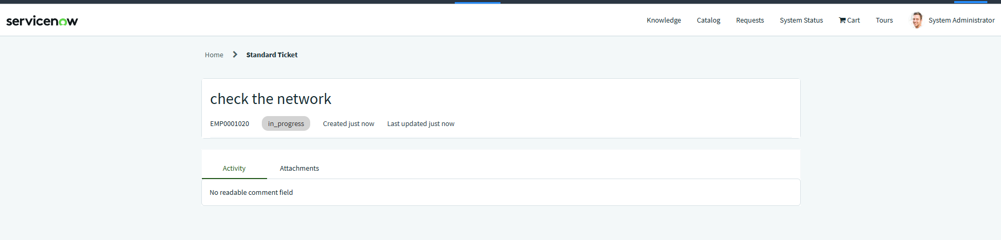

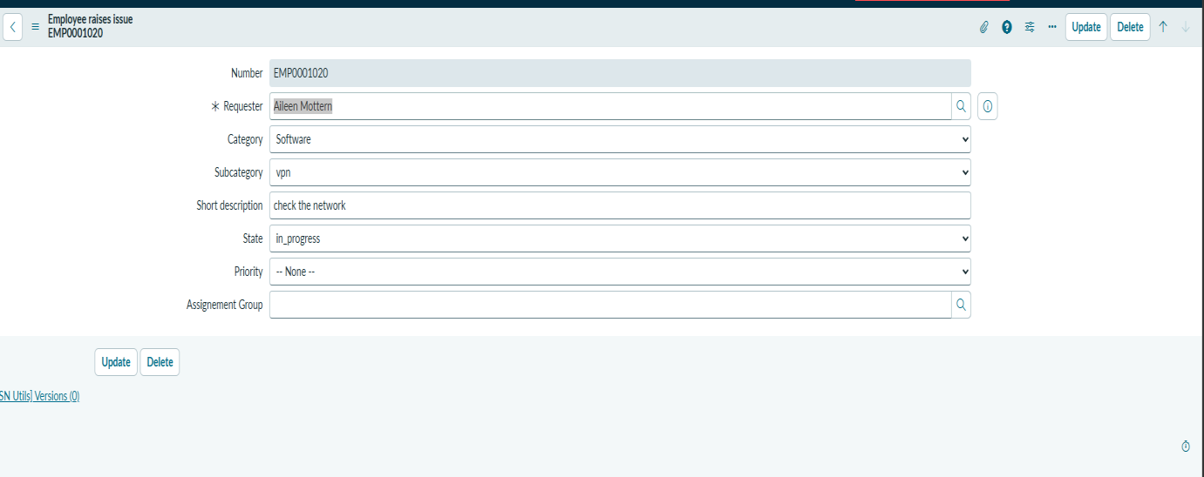

Conclusion :
The Employee Raise Issue project was developed in ServiceNow to provide employees with a simple and organized way to report workplace issues.
The project includes a custom Employee Raise Issue table, Record Producer, Category and Subcategory dependency, UI Policies, and a dedicated Service Portal.
The Category and Subcategory dependency ensures that users select relevant options, such as Network → VPN and Hardware → Laptop. The Record Producer allows employees to submit issue details through a simple form.
The Service Portal provides an easy interface for employees to raise issues, while the backend table stores and manages the submitted records.
Overall, the project helps standardize issue submission, improve data accuracy, simplify issue tracking, and support faster issue resolution.

